Math-Positive Mindsets:
How to Leverage Family Engagement to
www.carriecutler.com
ccutler@uh.edu

Maximize Students' Learning Potential
Dr. Carrie S. Cutler, University of Houston
2021 NCSM Annual Conference, Atlanta, GA Virtual

Why Mindset Matters
- Children’s beliefs about the malleability of their mathematical ability significantly impacts motivation, effort, and approach to mistakes and challenges.
- Those who believe their abilities are malleable are more likely to embrace challenges and persist despite failure. Growth mindset can be taught explicitly.
- Our outreach to parents and families makes a difference in outcomes for students.

Why Familial Mindsets Matter
- Research shows familial influence on learning is formidable and enduring.
- Children emulate parents’ attitudes. Their families are their first resource for beliefs.
- Homework is much less stressful when ALL involved in the process believe that effort, not natural talent, bring success.
- Research support (Drs. Dweck, Boaler, Master, etc.) can assist skeptical but willing-to-learn families to learn how the brain of a child is malleable and how mistakes in math are the space for learning.

Strategies for Passing Growth Mindset on to Families

- Activities for Family Math Night
- Malleability and Mindsets Movement Activity
Make line on floor using masking tape. Tell families to imagine this is our continuum of malleability. How malleable do you think certain traits are? MOVE LEFT—NOT Malleable MOVE RIGHT—Malleable. There are no right or wrong answers. The goal is to explore your own beliefs and see how others think. No commenting on others’ position unless you’re invited to do so. Traits to explore: eye color, hair color, creativity, shyness, intelligence, athletic ability, math ability, musical ability. --source: www.perts.net

- Brain Growing Game
Stand in circle. Start a web by describing math in your day, “I use math when I figure the unit price of peanut butter.” Hold the end of the yarn and throw the ball to someone across from you. Repeat until a web is formed. Each person represents a brain cell (neuron). The string represents pathways, or synapses. By engaging in mathematical processes, we grow our brains and build pathways. Ask someone to tell a challenge in math. Give multiple strategies, repeatedly tossing ball of yarn between you to show how multiple experiences make connections thicker and stronger.

- Wall of Mistakes
Families use sticky notes to celebrate mistakes. Use bulletin boards to convey that mistakes are not shameful but spaces for learning.
- Growth Mindset Quotes
Families create posters to display at school or on the school’s social media. Involving the whole family builds school---home connections.

- Growth Mindset Memes
Use free apps to upload photos from family phones. Post the memes on school social media. Email to teacher to print out and display. Involving the whole family increasing feelings of engagement.

- Class Newsletter
- Growth Mindset Corner of newsletter focused on Beliefs to Actions, Growth Mindset Language, Growth Mindset Websites, and Celebrations of Growth Mindset in our classroom

- Growth Mindset-Oriented Parent Conferences
- Data—Effort, Reactions to challenge & mistakes, Progress & processes over products
- Reflection--Include students’ self-evaluations about their effort and persistence
- Goal Setting--Challenging oneself not competing against others, Emphasize progress.

- At-Home Activities
- Website Explorations
  - Video by Class Dojo & Carol Dweck https://ideas.classdojo.com/i/growth-mindset-1
  - GM in popular children’s shows https://www.youtube.com/watch?v=LmW3H-EXYS0
  - Sesame Street does GM https://www.youtube.com/watch?v=SnrHZ_uvtxk
https://www.youtube.com/watch?v=XLeUvZvuvAs&feature=youtu.be
  - Proctor & Gamble 2014 Olympic Games Thank You Mom https://youtu.be/zsZ5yOImHQQ

- Take-Home Book Bags with GM Picture Books. Download from Carrie’s website.
  - Pancakes for Breakfast (dePaola, 1978)
  - Counting Crocodiles (Sierra & Willenbrand, 1997)
  - One Bright Ring (Géser, 2013)
  - A Chair for My Mother (Williams, 1982)
  - Ish (Reynolds, 2004)
  - The Dot (Reynolds, 2003)

- Mistakes on the Fridge
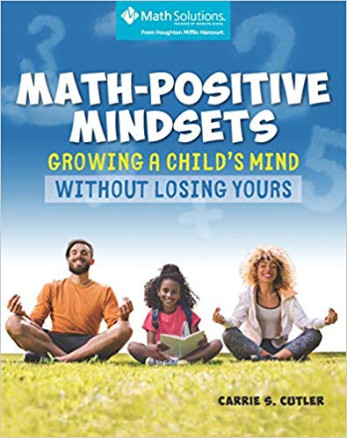
In addition to a corkboard or a fridge filled with children’s achievements, have a safe space where family members can brag about their biggest mistakes and what they learned from them. We need to flip the meaning of mistake from shameful and embarrassing to valuable learning space.

**For more ideas about cultivating the mindsets of families, please see Math-Positive Parents: Growing a Child’s Mind without Losing Yours (Math Solutions, 2020). Great door prize for family math night, PD sessions, and more!

